Title: Transforming Agriculture: The Evolution of Robotic Cultivation Systems

1. **Abstract:**

At the heart of these autonomous systems are four-wheeled robots driven by DC motors that have contributed to the development of sophisticated agricultural machines. A smart device can manage the field independently by marking specific lines and adjusting each line to a specific distance according to the specific crop. The system includes problem detection using infrared sensors. The entire algorithm (including computation, processing and monitoring) consists of a motor and sensor complex that is seamlessly connected to a microcontroller. This article focuses on real results obtained by simulating DC motors using feedforward and feedback techniques and shows results obtained from actuation cells. The focus is on modeling, analysis, and control using MATLAB and stimuli, illustrated by examples such as DC motors and maglev systems.

1. **Introduction:**

Agricultural Revolution: The emergence of Robotic Farming Systems is a major advancement in the integration of agriculture and robotics. This study shows how the industry is using DC motors worldwide to deliver performance and efficiency in new construction. From identifying problems to complex systems, we cover the complex processes that create traditional agricultural practices. Start this journey with a few flowers in the fields. These programs represent the future of agriculture through smart technology.

1. **Farming Processes and Cultivation System:**

In the expansive realm of agricultural practices, diverse processes and systems converge to ensure effective crop production and sustainable land management. These intricate methods encompass various stages, from soil preparation to the final harvest. Permit’s delve into some crucial aspects:  
  
**1. Soil Preparation:**  
- Prior to planting, farmers ready the soil to establish an optimal environment for seeds or seedlings.   
- Techniques such as plowing, harrowing, and tilling are employed to break up soil clumps, enhance aeration, and improve drainage.   
- Soil testing is conducted to assess nutrient levels and pH, guiding the application of fertilizers.   
  
**2. Planting and Sowing:**  
- The choice of planting method is determined by the crop type and local conditions.   
- Direct seeding involves placing seeds directly into the soil, while transplanting utilizes seedlings grown in nurseries.   
- Precision planting ensures uniform spacing and depth to facilitate optimal growth.   
  
**3. Crop Management:**  
- Crop rotation is employed to prevent soil depletion by alternating different crops in the same field.   
- Integrated pest management (IPM) combines biological, chemical, and cultural practices to control pests.   
- Water management incorporates irrigation systems tailored to specific crop needs.   
  
**4. Harvesting:**  
- Timely harvesting is crucial, considering that different crops mature at varying rates.   
- Mechanized harvesting involves the use of machinery such as combine harvesters to enhance efficiency.   
- Post-harvest handling is implemented to preserve and store quality.   
  
**5. Cultivation Systems:**  
- Conventional Tillage involves plowing and soil turning, but it may result in erosion and organic matter loss.   
  
- No-till farming minimizes soil disturbance, preserving its shape and lowering erosion.   
- Strip Cropping alternates rows of different crops to prevent soil erosion and enhance biodiversity.   
- Terracing creates flat areas on steep slopes, preventing soil erosion and conserving water.   
  
It's essential to note that each region and crop may necessitate specific adaptations, but these foundational processes collectively constitute the core of successful agriculture.

1. **Methodology:**
2. **Advanced Agriculture:**

* The focus of advanced agriculture is to elevate farming practices through the incorporation of technology, incorporating both hardware and software elements.
* Utilizing a combination of IoT, drones, robots, machinery, and artificial intelligence, it aims to oversee agriculture, farming operations, and associated activities.
* The main goal is to enhance agricultural processes by leveraging data from diverse sources, including historical, geographical, and technical information.

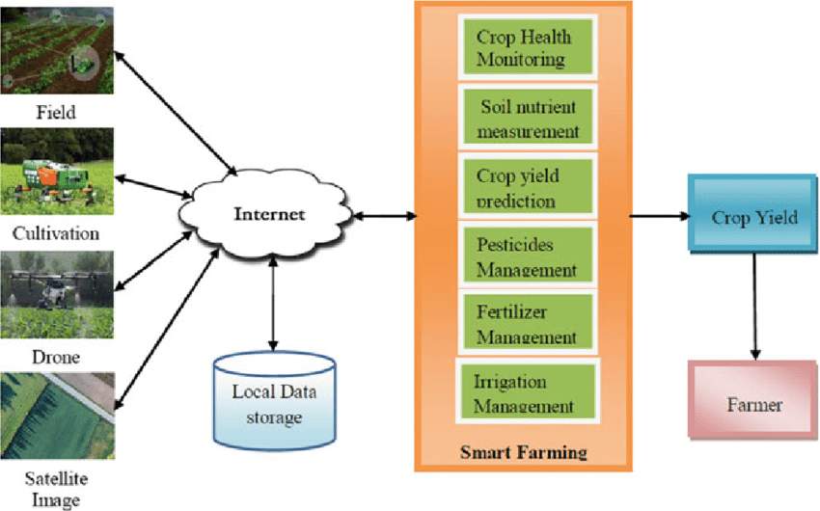

1. **Precision Agriculture**:

* Precision agriculture involves the integration of cutting-edge technologies, including robotics, temperature and humidity sensors, weather monitoring systems, and GPS technology.
* These advanced tools are employed to enhance business efficiency, increase productivity, ensure safety, and promote environmental protection.

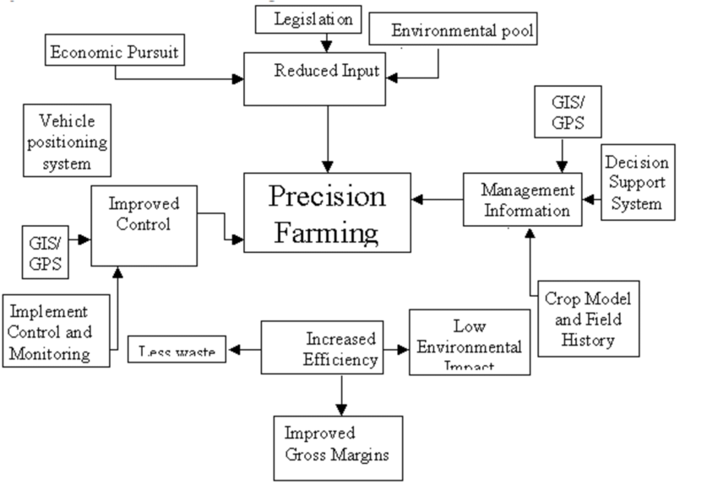

1. **Agricultural System Modeling:**

* Agricultural system modeling, integration of water, soil, crops, agricultural products and used for measurement. The impact of management practices and climate on the stability of agriculture.
* This model plays an important role in food security by simulating plant physiology and growth based on Eco physiological processes. In the dynamic field where tradition and progress meet, methodologies play an important role in shaping the future of food production.

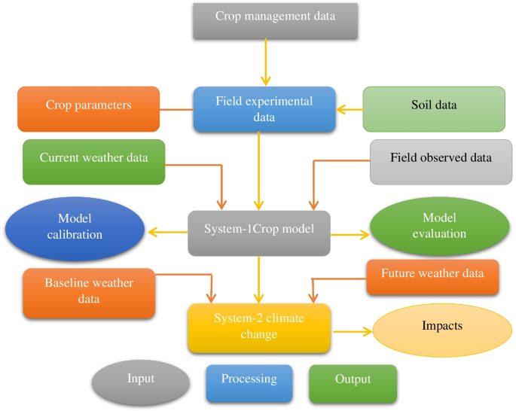

1. **MISSION PLANNING OPERATION**

Mission planning plays an important role in making robotic systems efficient, especially in agriculture. The following is important information on planning a path for agricultural robotics:

**1. Path Planning for Agricultural Ground Robots :**

* Ascending In order to meet the need to benefit from the world population, technology and automation must be adopted in agriculture.
* Ground robots designed for various agricultural applications face the challenges of autonomous control and safe navigation.
* The route planning process has important functions such as placement, mapping, movement control and especially the route itself.   
    
  **2. Cooperative control concept of robot swarm:**
* Robot swarm with many robots that can limit the robots created Built-in positioning functions, various It relies on collaborative control strategies to accomplish tasks.
* This rule prohibits combat by distinguishing between robot workers (operational workers) and support workers (supporting workers to move).
* These limitations should be taken into account when planning the best target.
* Provides a new way to plan concurrent work, highlighting the main stages:   
  **Division of labor:** Assign responsibilities to staff and support robots.   
  **Jobs for robot workers:** Assign specific tasks to individual robots.   
  **Worker Robot Path Planning:** Determine the best path for the worker robot.   
  **Move Simultaneously:** Facilitate the simultaneous movement of groups of workers.   
  **Communication:** Coordinates and supports the movement of robots.   
    
  **3. Backorder estimator:**
* Created backorder estimator to verify the computational resources required by the method.
* The estimator estimates the potential improvement in performance based on underperformance.
* Achieving a prediction error below 5% by using machine learning models.

1. **ALGORITHM IMPLEMENTATION**

**1. Selective Harvesting Robotics:**

* The selective harvesting of valuable crops like apples, tomatoes, and broccoli currently relies heavily on human labor, making it a labor-intensive and costly agricultural task.
* There is a significant interest in developing selective harvesting robots to address challenges related to variation, incomplete information, and safety concerns.
* Researchers have explored the latest advancements in selective harvesting robotics across three production systems.

**2. Algorithm Design and Integration for Robotic Apple Harvesting:**

* In the context of apple harvesting, researchers have seamlessly integrated core modules to create an efficient robotic apple harvesting system.
  + **Visual Perception:** Utilizing deep learning for multi-view fruit detection and localization.
  + **Unified Picking and Dropping Planning:** Ensuring optimal picking and dropping strategies.
  + **Dexterous Manipulation Control:** Enabling precise handling of fruits.

1. **Automating Agroecology:**

* The rising global demand for agricultural products necessitates automation in response to labor shortages, an aging farming population, and physically demanding tasks.
* While crops like wheat and corn ripen uniformly, high-value crops such as apples, tomatoes, and broccoli exhibit heterogeneous ripening, demanding selective harvesting of ripe fruits.

**4. IoT-Based Smart Agriculture:**

* Algorithms play a pivotal role in IoT-based smart agriculture systems, contributing to tasks such as fruit detection, quantification, ripeness checking, and disease detection.

**5. Versatile Agricultural Robot Design:**

* A versatile design for agricultural robots incorporates a skid-steering system to enhance traction, control, and maneuverability.
* The inherent stability of this robot design ensures effective adaptation to diverse terrains.

In summary, the implementation of algorithms in robotic cultivation systems spans various domains, from selective harvesting to fruit detection and manipulation control. These technological advancements significantly contribute to achieving more efficient and sustainable agricultural practices.

1. **EXPERIMENTAL RESULTS**

The assessment of the steering-based automated system's effectiveness involved a comprehensive series of tests conducted in cultivated fields featuring diverse crops such as groundnuts, jawar, and wheat. The planting of ten rows for each crop was meticulously executed using a one-row planter, ensuring a uniform planting pattern. The experimental outcomes provided valuable insights:

1. **Relationship between Vehicle Speed and Soil Moisture:**

Agricultural robots are widely acknowledged as a promising solution to address challenges in the agriculture industry, designed for various operations throughout the crop production cycle, from seeding to final harvesting. Harvesting and weeding, being labor-intensive tasks, have attracted significant attention. The focus on versatility has brought multi-purpose robots into the spotlight, as their ability to perform multiple tasks enhances their value and ensures a quick return on investment (ROI) - a compelling factor for growers. The trends depicted in Figure 4 illustrate the impact of ROI and labor considerations on robot development, highlighting differences between commercial robots for specific tasks and those developed by academia.

Companies primarily concentrate on operations such as weeding and harvesting, while academic institutions cover a broader spectrum, including crop scouting, weeding, harvesting, and multi-purpose functionality. Complex solutions are often required for tasks like harvesting and multi-purpose operations, drawing attention and providing exposure for the university or research center to a wider audience.

The trends outlined in Figure 4 vividly depict these dynamics.

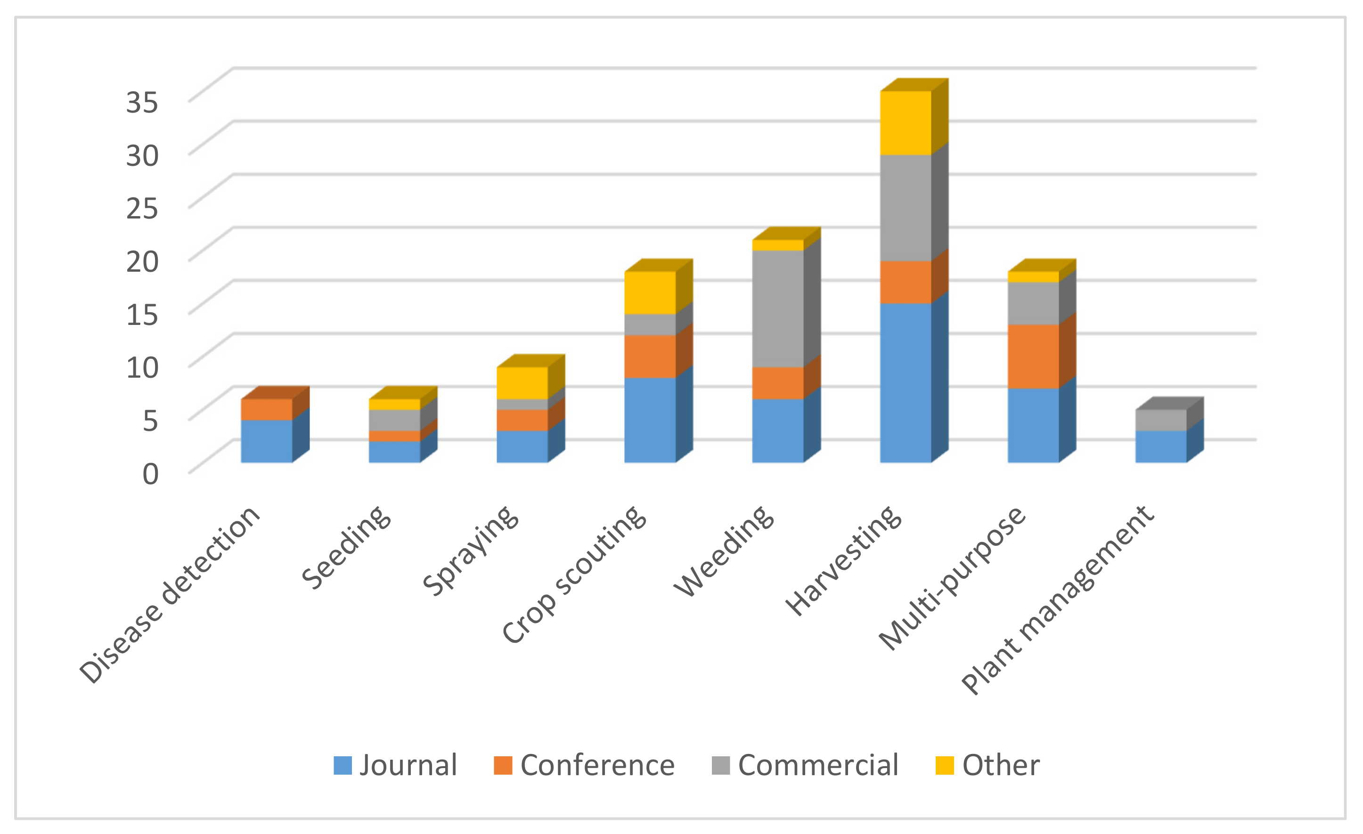

Figure 4. Number of reviewed robots per field operation

1. **Speed torque characteristics of DC motor:**

The DC motor operates at 12V with a rotational speed of 60 rpm. The torque-speed characteristics under full load conditions are illustrated by systematically increasing the armature voltage linearly from 1V to 12V. 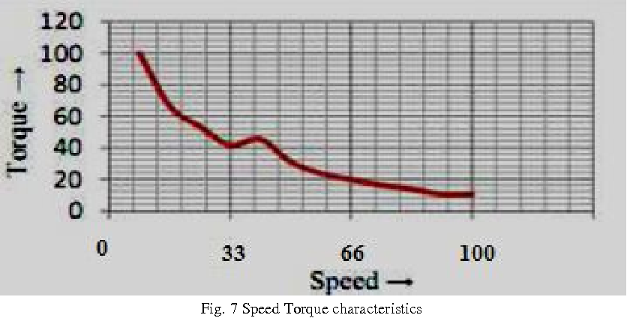

1. **D.C. motor speed analysis with and without feedback:**   
   The graphical representation illustrates two approaches aimed at minimizing the sensitivity of angular velocity (?) to variations in load, specifically changes in torque resisted by the motor load. The graph presents a comparative analysis of the closed-loop Bode diagram and its simulation in the presence of a back electromotive force (back e.m.f.) constant (Eb=0.085). The simulation incorporates both feedforward and feedback components, as depicted. 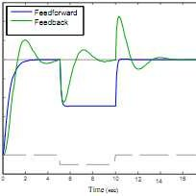
2. **FUTURE IMPLEMENTATION**

The system integrates an advanced moisture sensor designed to assess soil moisture levels in agricultural land. This feature enables the automatic regulation of the soil's water content, tailored to meet the specific requirements of the particular seed in use. Additionally, the system facilitates the augmentation of soil moisture during the water supply process. An alternative application involves utilizing the system for the targeted distribution of fertilizers instead of conventional seed sowing.

Moreover, the system is adaptable to extensive refinements, expanding its utility to measure various parameters critical to farming. This includes monitoring crop growth progress, identifying weed prevalence, and distinguishing between different weed types. The incorporation of a GSM system enhances the system's functionality by enabling remote monitoring of single or multiple systems. This integration proves to be an effective means of ensuring meticulous oversight and control over agricultural processes.

1. **CONCLUSION**

In conclusion, this paper delineates the prerequisites and progress achieved in the development of a prospective precision autonomous farming system. The engineered assembly is expressly designed for the automated cultivation of ploughed land, thereby obviating the necessity for manual labor. The project unfolds through the orchestration of two distinct mechanisms: the first focuses on the assembly and control of the vehicle's motion, while the second is dedicated to the meticulous preparation of a seed bed on the ploughed land.

At the core of this system is the pivotal role played by a microcontroller, which governs and monitors the intricate motions of the vehicle. These motions are executed with the assistance of DC motors and servo motors. Moreover, the integration of an infrared sensor enhances the system's capabilities by detecting obstacles in the vehicle's path and ensuring precise turning positions at the conclusion of the land. With its autonomy from human labor and commendable operational efficiency, the system holds considerable promise for further expansion and refinement.